**How to compile and run**

**WITHOUT GRADLE:** Download the project from git, extract it then run the Class MainRun.java in the package Global in Eclipse Workspace.

**WITH GRADLE:** After you have downloaded all the project from git, take the zip file “GradleVersion.zip”, extract it, open the CMD in the exact folder you have extracted it (where you see the ‘build.gradel’ file).

Now you should write ‘gradlew GUI’ then press ENTER. (this will install gradel on your computer via Gradle Wrapper and launch the application).

In case you already have Gradle installed in your computer, in the CMD you can write ‘gradle GUI’.

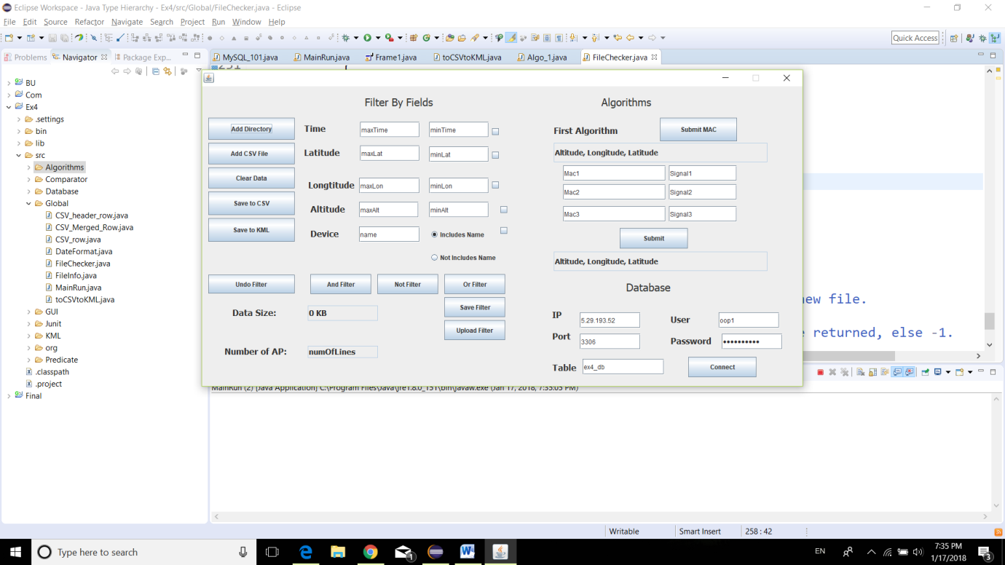Then you will see the window:

**General Buttons**

**Add Directory** – when you select the folder that contains the WiggleWIFI CSV (the application input) you also enable a new thread that watches for changes and updates the MergedCSV file automatically (Save to CSV and Save to KML) if a change in one of the input files detected.

This button is used mainly for filtering the data.

**Add CSV File** – when you select an already MergedCSV file you also enable a new thread that watches for changes and updates the First Algorithm file automatically if a change in the MergedCSV file was detected.

This button is used mainly to run the Algorithm on the data.

**Clear Data** – Clears the data that was in the MergedCSV and the KML. If there wasn’t any data to clear it will simply create an empty file.

The field **Data Size** is showing the size of the file/folder that is selected in kb.

The field **Number of AP** is showing the number of different MAC addresses from the selected folder.

**Save to CSV** – Save the WiggleWIFI data to the MergedCSV. To use this button you have to add a directory first.

**Save to KML** – Save the WiggleWIFI data to a KML file. You can upload it to Google Earth and see the trace of the coordinates, also allows you to view the TimeStamp. To use this button you have to add a directory first.

**Filter By Fields**

**Demands: Cannot use these without first selecting a folder via Add Directory button and then saving the data to a MergedCSV via Save to CSV button.**

To filter by time, latitude, longitude, altitude and device name you need to put maximum and minimum values then select the check box and submit one of the filters:

**And Filter** – All that is included in the different ranges chosen.

**Not Filter** – All that is not included in the range.

**Or Filter** – All that is in range of one of the chosen filters.

Another filter you can apply is by device name – either it includes it either it doesn't.

**Undo Filter** – After you have filtered all the data, you can undo everything and get the full MergedCSV file you had before you choose to filter it.

**Save filter** – Saves the settings you defined in the filter as a bin file. (Saves a filter as an Object).

**Upload Filter** – Uploads the filter settings that the bin file contains. (Uploads the filter as an Object).

**Algorithms**

**Demands: Cannot use these without uploading a MergedCSV file via Add CSV File button.**

**Submit Mac** – Calculates the coordinates of Mac and it's Signal in a MergedCSV table and creates a CSV table of it's own with the already calculated coordinates.

**Submit** – Reffers to the 6 fields above it; First you enter 3 Macs and their signals and in the read-only field beneath it you get the calculated coordinate where the measurement was taken. You can enter only one pair of the fields (Mac and it's signal) and fill the rest with zero's, but it's highly recommended that you enter all the data for a more exact coordinate.

**Database**

**Demands: Cannot use these without first selecting a folder via Add Directory button.**

The default values of the text fields are of the mySQL table we were told to use in the course.

**Connect** – after filling all the data (IP, port, username, password and table) or using the default values, you will get a prompt message whether the connection was established.

Now if you want the data from the mySQL table to be added to the MergedCSV table you need to press the Saved to CSV button, then not only the data from the database will be added but you will also enable a new thread that watches for changes and updates MergedCSV file if there was detected a change in the mySQL table.